**TABLESPACES Y DATAFILES**

**CONCEPTO**

Un Tablespace es una unidad lógica que denota el espacio de almacenamiento de datos dentro de una base de datos y que están constituidos por uno o más Datafiles.

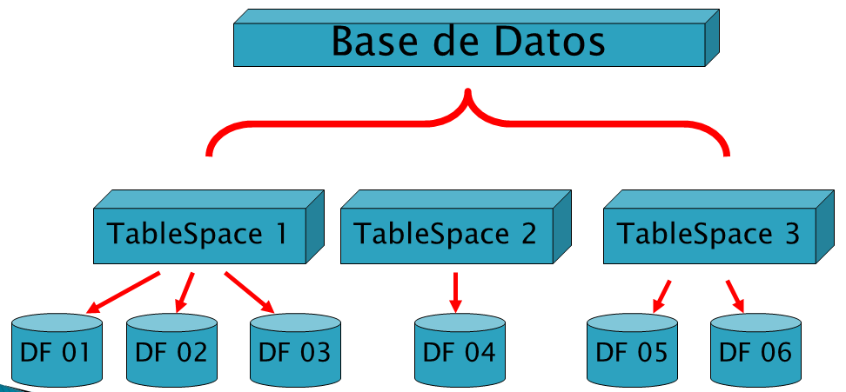

*----------------------------------*

*-- 1. CREACION DE TBS*

*----------------------------------*

CREATE TABLESPACE TB_VENTAS

DATAFILE 'C:\BDORACLE\DF_VENTAS_01.DBF'

SIZE 3M;

*----------------------------------*

*-- 2. CONSULTA ADMINISTRATIVA DE TBS*

*----------------------------------*

SELECT * FROM DBA_TABLESPACES;

*----------------------------------*

*-- 3. CONSULTA ADMINISTRATIVA DE DATAFILES*

*----------------------------------*

SELECT FILE#, NAME FROM V$DATAFILE;

*--------------------------------------------------------*

*-- 4. CONSULTA DE TAMAÑO Y PORCENTAJE DE ESPACIO LIBRE*

*--------------------------------------------------------*

SELECT /* + RULE */ df.tablespace_name "Tablespace",

df.bytes / (1024 * 1024) "Size (MB)",

SUM(fs.bytes) / (1024 * 1024) "Free (MB)",

Nvl(Round(SUM(fs.bytes) * 100 / df.bytes),1) "% Free",

Round((df.bytes - SUM(fs.bytes)) * 100 / df.bytes) "% Used"

FROM dba_free_space fs,

(SELECT tablespace_name,SUM(bytes) bytes

FROM dba_data_files

GROUP BY tablespace_name) df

WHERE fs.tablespace_name (+) = df.tablespace_name

GROUP BY df.tablespace_name,df.bytes

UNION ALL

SELECT /* + RULE */ df.tablespace_name tspace,

fs.bytes / (1024 * 1024),

SUM(df.bytes_free) / (1024 * 1024),

Nvl(Round((SUM(fs.bytes) - df.bytes_used) * 100 / fs.bytes), 1),

Round((SUM(fs.bytes) - df.bytes_free) * 100 / fs.bytes)

FROM dba_temp_files fs,

(SELECT tablespace_name,bytes_free,bytes_used

FROM v$temp_space_header

GROUP BY tablespace_name,bytes_free,bytes_used) df

WHERE fs.tablespace_name (+) = df.tablespace_name

GROUP BY df.tablespace_name,fs.bytes,df.bytes_free,df.bytes_used

ORDER BY 4 DESC;

*----------------------------------*

*-- 5. CREANDO TABLA EN TB_VENTAS*

*----------------------------------*

CREATE TABLE CURSO

( ID NUMBER,

NOMBRE CHAR(50) )

TABLESPACE TB_VENTAS;

*----------------------------------*

*-- 6. INSERTANDO 10 MIL REGISTROS*

*----------------------------------*

INSERT INTO CURSO

SELECT LEVEL , 'CURSO' || LEVEL

FROM DUAL CONNECT BY LEVEL <= 10000;

*----------------------------------*

*-- 7. MODIFICANDO TAMAÑO DE DATAFILES*

*----------------------------------*

ALTER DATABASE

DATAFILE 'C:\BDORACLE\DF_VENTAS_01.DBF'

RESIZE 10M;

*----------------------------------*

*-- 8. AGREGANDO UN NUEVO DF AL TBS*

*----------------------------------*

ALTER TABLESPACE TB_VENTAS

ADD DATAFILE 'C:\BDORACLE\DF_VENTAS_02.DBF'

SIZE 10M;

*----------------------------------*

*-- 9. CAMBIANDO EL ESTADO DEL TBS*

*----------------------------------*

ALTER TABLESPACE TB_VENTAS OFFLINE;

ALTER TABLESPACE TB_VENTAS ONLINE;

*----------------------------------*

*-- 10. ELIMINANDO LOS TBS*

*----------------------------------*

DROP TABLESPACE TB_VENTAS

INCLUDING CONTENTS AND DATAFILES;